**Final Report**

**3-D Markerless Motion Capture and Positioning System for Active Shooter Response Training**

**Project Manager: Bo Heyse**

**Matthew Healea, Karina Paz**

**Texas State University**

**Ingram School of Engineering**

**Texas State University**

**602 University Dr.**

**San Marcos, TX 78666**

**Date**



Remove this box and put an approved Sponsor logo in this space ONLY if your Sponsor approves doing so.

If they do not, center the UNM logo.

**Test Plan Revision History**:

# Overview

## Executive Summary

Our project was sponsored by the Texas State University ALERRT Center. The ALERRT Center upholds the national standard to provide the best research-based active shooter response training in the nation. The Center is free for police municipalities to attend, but that does not factor in travel and man-hour expenses. With a team made up of three electrical engineering undergraduate students, we set out to find a solution to allow for active shooter trainings to be easily accessible. Our project’s goal is to help provide simple access for the scenarios the training entails.

This will be done by obtaining motion data from a Golden Standard – scenario done by professional first responder(s) – run through of the training to then be rendered in virtual or augmented reality. By designing a system that captures data in a three-dimensional (3D) plane for pitch, roll, and yaw – rotation side-to-side, rotation front-to-back, and rotation around the vertical axis, we can obtain motion data to show the movement and trajectory of a responder.

can be scalable

*This section should present a clear, concise summary of your project.* ***[3/4 page limit]***

* *who sponsored it,*
* *size of team & mix of major/track,*
* *what your project was intended to do,*
* *how closely you achieved your goals,*
* *in general (concise!) what worked well and what didn't, and briefly summarize which features met design specifications and which did not. Write this section so that if a VP is only going to read one section about whether or not your project worked - this would be the one.*

*NEW PARAGRAPH:Describe the purpose & value of your project. Why did you do it? Who benefitted? How is it of value to your Sponsor/TXST/society/you, etc?*

## Abstract

Live shooter training is limited in availability to smaller municipalities throughout this state and many others. Our senior design project aimed to eliminate as many of these availability issues as possible through the development of a virtual representation of highly trained professionals delivering a Gold Standard performance of a live shooter scenario. Our system will capture the motion data and trajectory of the trained professionals as they navigate a live shooter scenario and record motion data at key locations such as the head, chest, and gun. In addition to capturing the data, the system allows the user to upload the data to a centralized location where it can be processed and prepared for a virtual recreation of the scenario. These virtual recreations can be used as training tools for all municipalities, enabling law enforcement everywhere to receive the proper training for these unfortunate events.

*Write a concise abstract for your project.* ***[1/4 page limit]***

*THESE SECTIONS ABOVE MUST FIT ON THIS PAGE!!*

From page 2 forward, this document shall have:

* 1” margins all around
* Right-justified or not is your choice
* Times New Roman 12 point (EXCEPT section headers) for text
* 1.15 spacing
* 0 points before, 0 points after
* Use block separation for paragraphs - NOT indentation

Delete this text box once you have understood and obeyed its commands.

Contents

1 Overview 2

1.1 Executive Summary 2

1.2 Abstract 2

2 List of Figures 4

3 List of Tables 4

4 Problem Description 4

5 Progress Towards A Solution 4

5.1 Design Decisions 4

5.2 Design Approach 4

5.3 Project Approach 4

5.4 Engineering Standards 5

5.5 Progress Towards Goals 5

5.6 Verification 5

5.7 Characterization Results 5

5.8 Deficiencies 5

5.9 Iterations and Redefinitions 5

6 Constraints 6

6.1 Budgetary 6

6.2 Design Feasibility 6

6.3 Manufacturability 6

6.4 Maintainability 6

6.5 Environmental 6

6.6 Health and Safety 6

6.7 Social 6

7 Budgets 6

8 Work Schedule 7

9 Personnel Interactions 7

9.1 Teamwork 7

9.2 Mentorship 7

10 Ethics 7

11 Summary & Conclusions 7

12 Discussion 8

12.1 Academic Preparation 8

12.2 Lessons Learned 8

12.3 Soft Skills 8

12.4 Schedule Deviations 8

12.5 Staffing 8

12.6 Final Observations 8

13 Acknowledgments 8

14 References 8

# List of Figures

# List of Tables

# Problem Description

In the United States alone there has been a total of 336 mass shootings reported, since October 15th [1]. Municipalities are facing the trouble of not having enough funding to provide the resources for proper training. Many first responders are given the basic training, but it is not enough insight to how they should physically react to an active shooter(s) scenario. For this reason, we are designing a three-dimensional motion capturing system. This motion capturing system is to record movement from well-trained first responders who will be running through different response scenarios.

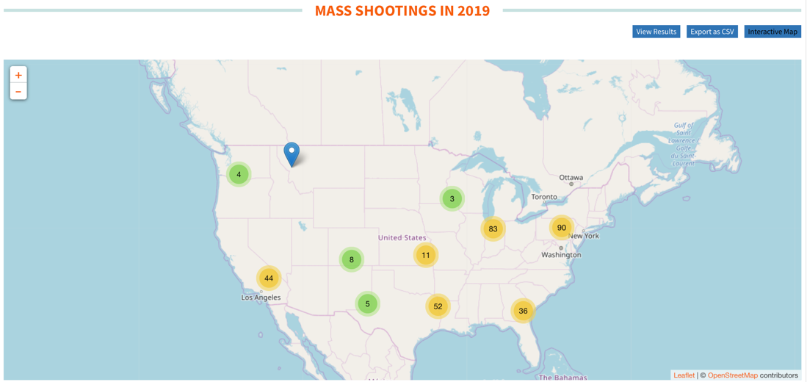

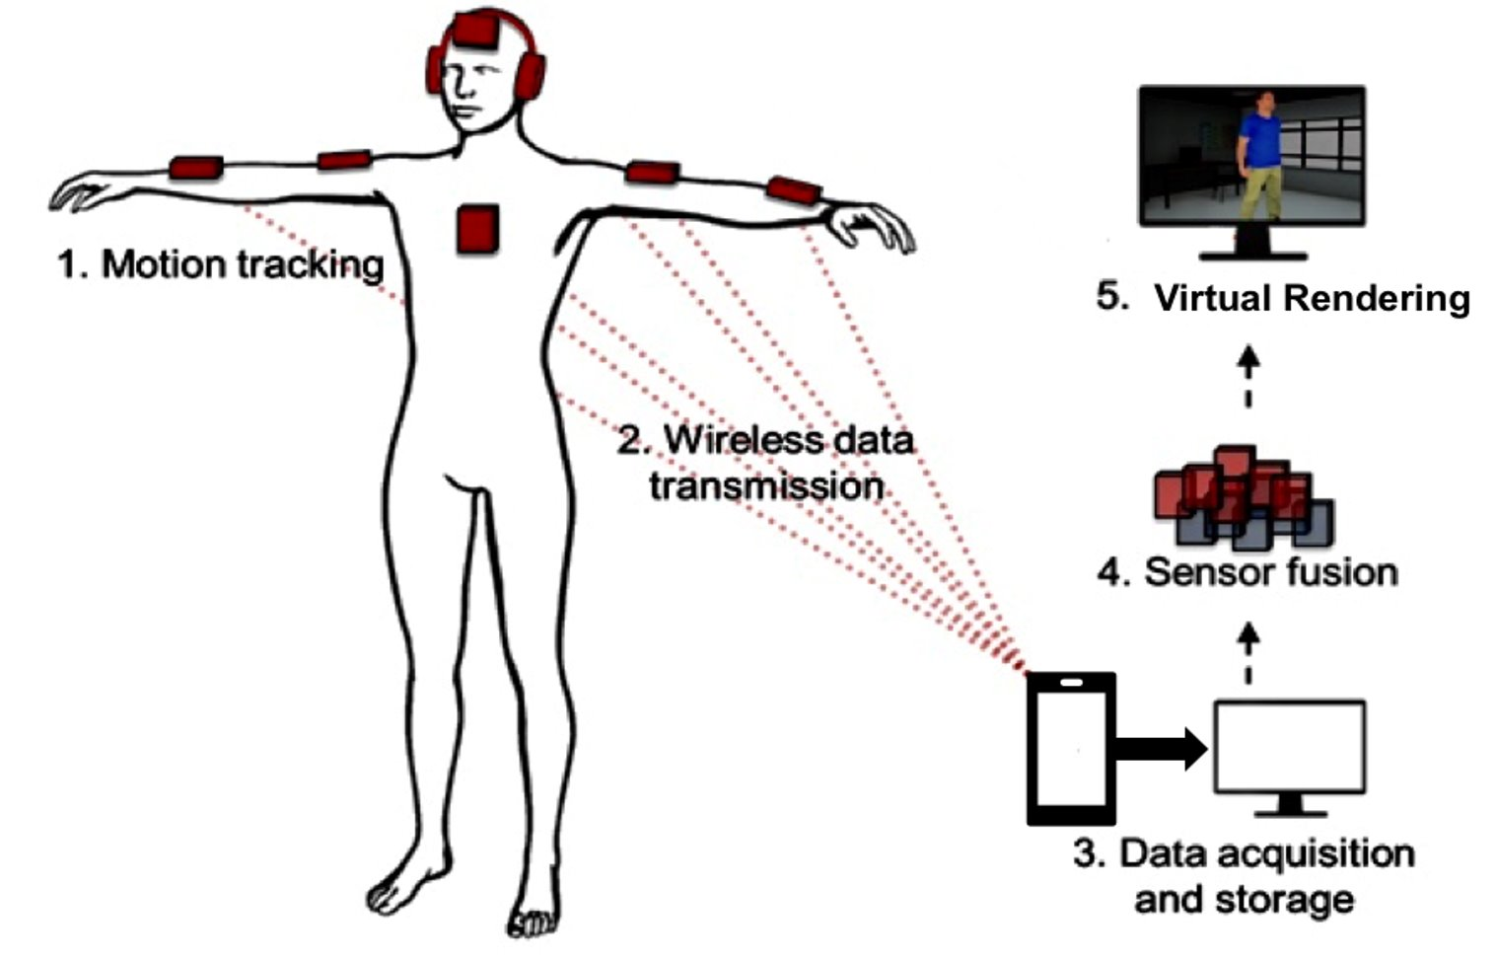

**Figure 1** System Level Diagram – displays how the system operates as a whole

It should be noted, we designed the mobile application and integration of the system components. Some components, such as the sensor firmware, were open source items that we integrated together to achieve our design.

*The problem description section should tell the reader the topic your project is addressing and your specific deliverable(s).*

**BE REALLY CLEAR ABOUT WHAT YOU DESIGNED/BUILT.**

*Include a system-level diagram that will orient a reader to your design approach. The system level diagram should be very general. It should, at a glance, make clear what your project does, how it fits together, etc. It shall be Figure 1. Your work shall be highlighted in yellow as shown. Here's a couple examples:* (THEY ARE NOT CORRECT!!)

# Progress Towards A Solution

## Design Decisions

Figure 2 illustrates our system design at a block level. Each bock is a carefully thought out design decision representing different subsystems of our project. This design implements considerations of a nonintrusive system, a simplistic user interface, and a crucial need for scalability. For the sensor subsystem, we chose to use inertial measurement units (IMUs) in place of attempting to wire cameras throughout the ALERRT Center’s establishment. In doing so, we have not only saved cost on the implementation of a camera system but have created a system that can be scaled to other facilities outside a single building of the ALERRT Center. We made this design decision by accounting for both cost to the ALERRT Center and the need to be able to scale and reproduce our project in varying environments. By using IMUs we are not restricted to a single building to capture motion data, this greatly improves the reach of our product and extends the use to more than just the ALERRT Center. The user subsystem was chosen as a mobile device for the familiarity for the user, ease of use and abundance of devices, and most importantly to maintain a scalable product. The alternative to a mobile device would be to construct a small standalone piece of hardware to implement the required connect/start/stop functionality necessary for this project. However, the familiarity to the user would be nonexistent, the cost of constructing such a device with comparable functionality is much greater than that of a used mobile device, and the amount of proprietariness of the system would have increased. Thus, the most desirable choice for this subsystem was to use a mobile device that localizes a system to the user and creates a tremendous amount of scalability for the project. The administrator subsystem was chosen as a personal computer (PC) because this is the most logical choice for data analysis and virtual recreation of a scenario. The administrator of the system will prepare the data for simulation using various software applications, none of which need be simplistic for user qualification purposes, as the administrator will be an on-site engineer.

*Discuss your design decisions for each block at the most general level: What alternative approaches to the design are possible, which was chosen, and why is it desirable? Include at least one figure to illustrate this*

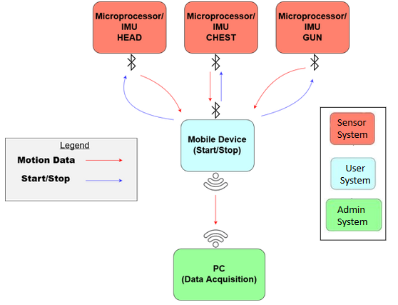

**Figure 2** Functional Diagram – depicts each functional block of the design and relationship between them

## Design Approach

A top-down approach was used to design our system. We first determined the overall functionality of the system, segmented that functionality into subsystems and created those subsystems through copious amounts of research and iterations of the subsystems. This project is one that has variations that have been attempted by many however, accurately executed by few. Finding the appropriate research was difficult, there are many ways to approach the problem of indoor motion tracking, whether it be RFID systems, near field communications, or marker-camera systems, all contribute their own advantages and weaknesses to the topic of motion capture. The portability and scalability of IMUs were what was most attractive to us and seemed to best fit the needs of the project. Figure 3 displays our software choices and how they related to the project in terms of use case. We used the Arduino IDE to outfit the opensource firmware to the project's functional needs. Xcode was used to create the mobile application to control the connect/start/stop functionality of the IMU. MATLAB was used to test displacement of sensors using captured data, and the Processing IDE was used heavily to visualize the orientation with respect to pitch, yaw, and roll of the sensors.

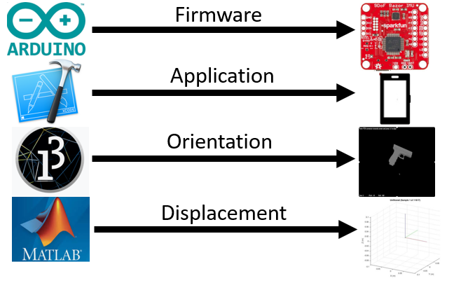

**Figure 3** Software Applications – displays software used to design different aspects of the project

*Design approach: how did you approach & do the design? What software tools did you use? Include at least one figure to illustrate this.*

## Project Approach

We decided to segment the project into separate discrete pieces, the hardware aspect that would include researching and choosing an appropriate IMU, wireless communication devices and how they would interface with one another. The second segment was the software aspect of the project which included the firmware for the IMU, a mobile device application to communicate and control the IMU, and data processing software to be able to visualize the recorded data. Each engineer focused on different aspects of either software or hardware and immediately began research on their topic. We checked in with one another each week to brainstorm ideas for new approaches to specific topics or discuss how to integrate our current pieces of the project together. For example, when the mobile device was realized to be the control unit for the IMU, we needed to ensure that the current Bluetooth module was compatible with the Bluetooth of a mobile phone, this resulting in us upgrading our Bluetooth module to a newer low energy version. Segmenting the project allowed us to continuously make progress on separate pieces of the project simultaneously and drive us to a working design.

*How did you approach & organize the project? What steps did you take to complete it?*

## Engineering Standards

*Each project incorporated relevant engineering standards from organizations such as ANSI, UL, IEEE, ASTM and so on. List each set of standards used in your design. For each standard state HOW and WHY it was relevant and how incorporated.*

*Feel free to do this in tabular form if you desire such as:*

|  |  |  |  |
| --- | --- | --- | --- |
| **Standard** | **Title** | **Application** | **Relevance** |
| UL44 | Standard for rubber-insulated cables & wires | Two, 2m RG59 cables from power supply to amplifier unit | Safety |
| GR-499-CORE | Transport Systems Generic Requirements | Optical fibers transmitting data from sensor unit to processor | Data Integrity |
|  |  |  |  |

## Progress Towards Goals

Once the details of the design were agreed upon by all, the process of achieving our deliverables was fairly explicit. We began work on hardware selection right away as this was a major controlling factor in determining the appropriate software. We made steady progress for nearly weeks until we were finally able to meet with the head of research at the ALERRT Center. He had a distinctly different idea of what our project was to achieve then we did. His thoughts on our project were that we were to create a two-dimensional real-time tracking system for first responders in training. After meeting him, we immediately set an appointment with our faculty advisor to discuss options for moving forward. This was the pivotal point in our project when we decided to put our stake in the sand and head that direction in terms of the scope of our project. This changed our deliverables from three-dimensional motion and orientation tracking to only orientation at several key locations of the responder. We came to the realization that accurate positional motion tracking from sensors alone, was an entire project, and required a technology and expertise that is yet to be invented. Once we settled on the specific scope of our project, we continued to work diligently at making progress on each functional deliverable until all were working and only needed a bit on fine tuning.

*Clearly indicate your progress toward achieving your proposed deliverables. If there was any change in your deliverables from those originally proposed, explain the reasons and provide justifications.*

## Verification

To verify our product we performed a number of tests to ensure we met the technical requirements specified early on in our project and to gain an understanding of the quantitative performance one can expect when using our product. The main aspect’s that were tested had to do with the wearable sensor system as well as the interaction of the wearable system with the mobile device.

Within the wearable sensor system we designed tests for the battery life, storage capacity, sampling frequency, sensor accuracy, and transfer rate. These tests were important in verifying our wearable system for a number of reasons:

1. Ensure our system has recording capacity for an entire training day (2 hours).
2. Ensure the data from our sensors is accurate and usable.
3. Data transfer speeds must be high enough as to not limit the usefulness of the system.

The interaction between the sensor subsystem and our mobile application subsystem are of crucial importance in order to propagate start/stop, error, and transfer signals. We designed tests to verify errors in the system such as:

1. Starting a recording session with no devices connected
2. Not receiving a return signal from the sensors after pushing Start or Stop
3. Receiving a battery signal of less than 20%
4. A device is disconnected mid recording
5. A data sample can not be written to the SD card

In the unlikely chance one of the above errors occur, our designed tests allow us to know and tweak how the system will handle each error it receives. Also, within the testing of the two subsystems, we verified our subsystem’s interaction speeds by designing a software test which calculates the roundtrip propagation delay.

## Characterization Results

|  |  |  |  |  |
| --- | --- | --- | --- | --- |
|  | **TEST CASE** | **SPECIFICATIONS** | | **Results/Compliance** |
|  |  | Input | Expected Output |  |
| 1 | Accelerometer Calibration | Slow rotation around each axis of the sensor (angular velocity) | Accelerometer operation range for each axis | Pass  {255, 255, 255} |
| 2 | Gyroscope Calibration | Sensor laying at rest | Gyroscope noise at each axis | Pass  {0, 0, 0} |
| 3 | Magnetometer Calibration | Sensor rotation to plot 10,000 samples around the X, Y, Z coordinate system | A set of transformed coordinates that the magnetometer origin will be offset | Pass  {443.807, -286.6533,  -76.155667} |
| 4 | Sensor Displacement Accuracy | A 90˚ rotation around a measured path. | An observed sensor reading within 25% of the expected reading | Pass  6.6% Error |
| 5 | Sample Rate | A 90˚ rotation around a measured path at sampling frequencies of 20, 25, 33, 40, 50 Hz | A sample rate with the best accuracy | Pass  40 Hz |
| 6 | Transmission Range | A specified distance and ground-truth text file | Fully operational, uninterrupted data transmission for a distance of at least 5 meters. | Pass  Unobstructed Path: 30.16 m Obstructed Path: 15.05 m |
| 7 | Battery Life | Sensor running at 40 Hz and writing to SD card using a 1 kB buffer. | 2-Hour operation time | Pass  13.03 Hour Life |
| 8 | Storage Capacity | 2 hours worth of writing data to SD card | A file size of less than 25 MB | Pass  6.07 MB |
| 9 | Transfer Rate | The file size of a one-minute recording at 40 Hz (67 KB) | File is received in less than 30 seconds | Pass  23 seconds |
| 10 | Battery Error | A battery capacity of less than 20% | Low Battery Alert on application | Pass |
| 11 | Storage Error | Full SD Card | Full SD Card Alert on application | Pass |
| 12 | No Devices Connected Error | Pushing Start without having connection to the sensors | Connect Devices First Alert on application | Pass |
| 13 | Sensor Unresponsive Error | Comment out sensor return signal code | Sensor not responding Alert on application | Pass |
| 14 | System Latency | Record UNIX timestamp when start is pushed and record UNIX timestamp when return signal is received. | A difference of 1 second or less | Pass  48 ms |

## Deficiencies

*For each deficiency, address the effect on system performance and design. Include any estimates of time and effort required for correction of each deficiency and any recommendations regarding the urgency of each correction, and the recommended solution or approach to correcting deficiencies.*

*Summarize in a table.*

## Iterations and Redefinitions

*Reproduce your project definition from the SOW. Now, contrast this with what you had as your project definition at the time of writing this report by answering the following IN DETAIL.*

*Describe each relevant/major iteration or redefinition. How or why did they occur? What were the circumstances? Roughly when did it occur? What was the impact? What did you learn from it?*

# Constraints

## Budgetary

*How did limited funds/supplies constrain your design?*

## Design Feasibility

*You're not Intel so how did this constrain your design? How did equipment and software limitations constrain your design?*

## Manufacturability

*What constrains the ability of your design to be manufactured? What constraints did you consider?*

## Maintainability

*This is mostly for software, but hardware systems may require maintenance.*

## Environmental

*What environmental considerations did you have? Think about this in broad terms!*

## Health and Safety

*What health and safety concerns did you consider as constraints?*

## Social

*Speak to constraints due to intended users/audience, etc.*

# Budgets

*The budget section should include a comparison of your proposed budget and the actual dollars spent to date. Create a table with side-by-side columns to convey this information.*

*Include a brief statement or paragraph summarizing your budgetary performance. Ignore items that differed by only a few dollars.*

# Work Schedule

*The schedule section must make clear to the readers which tasks were completed and which were not. Wherever possible make it clear which team member(s) were responsible for each* ***major*** *task. Discuss any timeline changes since the proposal was submitted. Use Gantt charting techniques (or side by side table if it’s preferable) to show the current status of the tasks in relation to the proposed schedule. However you do this it has to be readable!!! It will be a Figure or Table.*

# Personnel Interactions

## Teamwork

*The teamwork section must clearly and concisely state the responsibilities of*

*each team member and his/her contribution to the senior design project. This is an expansion of Section 8. You can convey this information in a method of your choice, i.e. text, table, etc.*

## Mentorship

*What role did your Technical Mentor (Sponsor) and Faculty Advisor play? How much time did you spend with them and how frequently? How much did they assist you? What did they do? (point you towards resources, chalkboard lectures, help solve problems when stuck, etc) Be specific and give examples whenever possible.*

You're tiptoeing on political turf here so be very careful how you word this. If you got very little mentorship from your Sponsor/Tech Mentor then perhaps they did a great job defining the project, pointing you in the right direction, asking pointed questions, etc.

# Ethics

*You must discuss the ethics associated with your project. Treat this like your Ethics Paper - write an analytical (NOT persuasive or opinion) essay. Use moral & ethical theories & principles as appropriate as you did in your Ethics Paper. Include elements of IEEE & NSPE codes of ethics as you did in your Ethics Paper.*

# Summary & Conclusions

*Describe the overall capabilities and deficiencies of the system. (This is the more technical and detailed version, which you will summarize for the Executive Summary.) Provide a statement, based on the results of the system or module test, concerning the adequacy of the system or module to meet project requirements. How close did you come to your objectives?*

# Discussion

## Academic Preparation

*Were your TXST EE courses useful preparation for your project? How much, and if yes, how? If not, why not? If not, what resources were used?*

## Lessons Learned

*What did you learn about the engineering process? Teamwork? Management?*

## Soft Skills

*What soft skills did you develop, improve or learn that you did not have before taking Senior Design? What elements of the course, or activities or assignments facilitated this learning?*

## Schedule Deviations

*What caused any deviation? What could you have done to better stay on track? What elements were under your control? Out of your control?*

## Staffing

*Was your project adequately/correctly staffed? Why or why not? Enough members? Right major/tracks?*

## Final Observations

*If you had this project to do over again, what would you have done differently?*

# Acknowledgments

*Briefly acknowledge the individuals who helped you technically, organizationally, etc.*

*At a minimum you must acknowledge your Sponsor and your Faculty Advisor. Be generous!*

# References

*List relevant references. This section provides a bibliography of key project references and deliverables. This should not be a long section, but should show that you referenced and followed applicable guidelines.*

[1] “Gun Violence Archive.” *Gun Violence Archive*, www.gunviolencearchive.org/reports/mass-shooting.